# A:\CBHE-factori\aa-starter\Factori_soumis\communication\logo\Logo Factori 4.0.png

# From Automation and Control Training to the Overall Roll-Out of Industry 4.0 Across South-East Asian Nations

# (ASEAN FACTORI 4.0)

**PROJECT No. 609854-EPP-1-2019-1-FR-EPPKA2-CBHE-JP**

**Second Training in Asia at Chulalongkorn University (PPP-train2) on November 14-25, 2022**

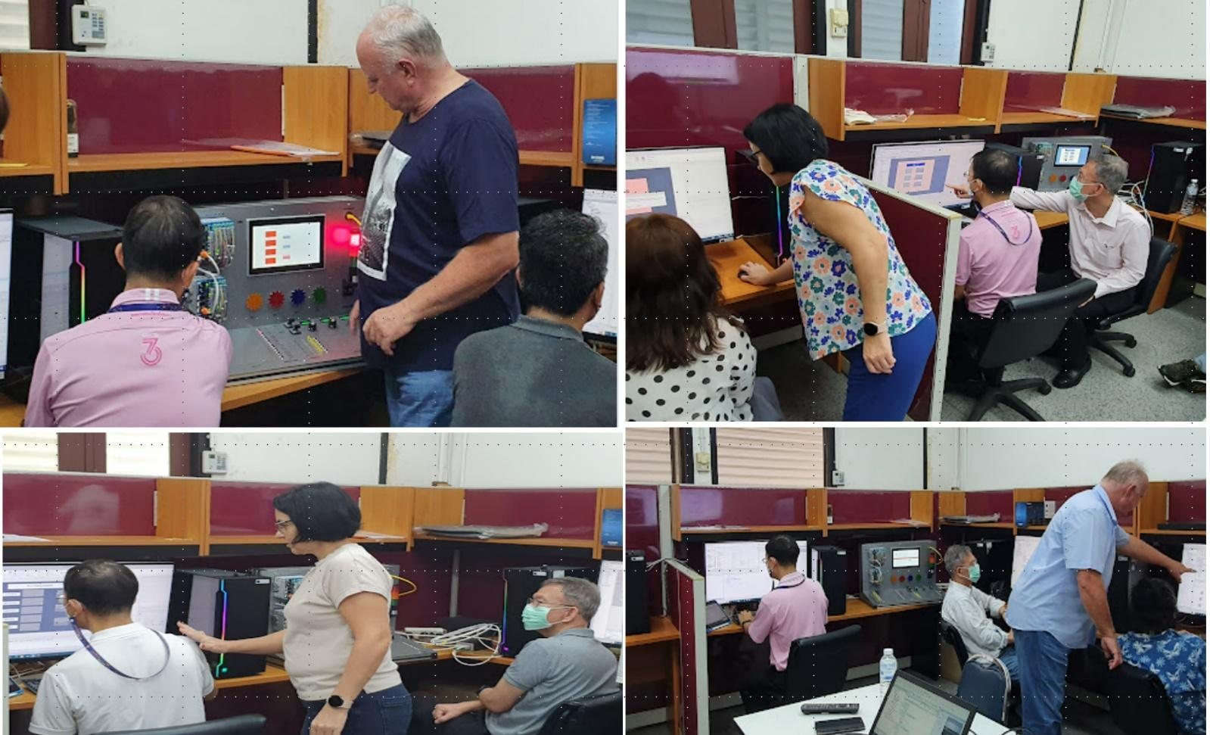

From November 14-25, 2022, Prof. Plamen Daskalov, PhD, and Assoc. Prof. Tsvetelina Georgieva, PhD, from University of Ruse “Angel Kanchev”, Bulgaria, conducted a training session as part of ASEAN Factori 4.0 supported by the ERASMUS+ Program of the European Union for Across South East Asian Nations: From Automation and Control Training to the Overall Roll-out of I4.0" (reference number: 609854-EPP-1-2019-1-FR-EPPKA2-CBHE-JP). The primary instructors from Chulalongkorn University for this project are Prof. Paisan Kittisupakorn PhD. from Department of Chemical Engineering, Prof. David Banjerdpongchai PhD. from Department of Electrical Engineering, and Instructor Sirikanya Singcuna from Department of Chemical Engineering.

The training aims to equip the instructors from Chulalongkorn University with the necessary skills to effectively plan lessons and laboratory activities related to programmable logic controllers (PLCs). The outcome was to ensure that students gain practical experience in coding PLC languages and witness firsthand how PLCs are applied in real-life scenarios. Additionally, the task involved installing CODESYS and GALILEO on all computers for the Intelligent Control Automation of Process Systems (ICAPS) laboratory within the Electrical Engineering Department at the Faculty of Engineering, Chulalongkorn University.

This installation process was successfully completed, ensuring that our students have access to the latest tools and platforms for their studies and practical experiments. Furthermore, the training involved testing the connection from the benchmark to all computers, resulting in successful connectivity and network integration. This crucial step ensures smooth communication and data exchange between devices, allowing for efficient and reliable PLC programming exercises.

Throughout the training, various PLC programming exercises were created, focusing on ladder diagram, function block diagram, and sequential function chart programming techniques. These exercises provide our staffs with hands-on experience in designing and implementing control logic using different programming languages, enabling them to develop comprehensive lessons in industrial automation for CU students.

We are grateful to Prof. Plamen Daskalov PhD. and Assoc. Prof. Tsvetelina Georgieva PhD. for sharing their expertise and contributing to the advancement of our educational programs. Their visit and the training sessions have played a pivotal role in equipping our staff members with the essential knowledge and practical skills needed to effectively prepare Chulalongkorn University (CU) students for success in the era of Industry 4.0. Conversely, training in Asia focuses on the installation of PLCs in computers within designated Center of Excellence (CE). This training emphasizes both hardware and software aspects, ensuring smooth delivery of materials to students.

Further, the University of Ruse “Angel Kanchev”, Bulgaria, actively supports Chulalongkorn University in creating various lessons, providing recommendations and suggestions for improvement. Additionally, the EU assists in utilizing PLC benchmarks effectively. This collaboration facilitates the development of comprehensive training materials that meet international standards and enhance the overall quality of education in the field.